Please note you are receiving this newsletter because at some stage you personally subscribed to the eNewsletter from the QAGTC website. If you wish to unsubscribe then do not reply to the email
Make sure you send a NEW email to qagtcgiftedcommunity-leave@lists.qagtc.org.au
Subject for the email is Leave In the body of the email please type Unsubscribe
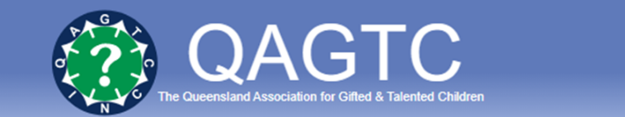
QAGTC 2023 News update 11th May 2023
www.qagtc.com.au
The first edition of Mindscape for 2023 has now been published and is on the website qagtc.org.au for access by financial members of QAGTC.
The issue contains some of the presentations offered at the State Conference held at the BCEC
on the 17th and 18th March 2023
Memberships – The website sends out a reminder message to members that their membership renewal day is coming up. Then a second message is sent closer to the expiry date. So to maintain membership please take notice of the messages. You can also see your membership status when you log in on the website and look at your account information which will show EXPIRED in red if it has not been renewed.
Activities – All QAGTC association activities are advertised on the website so please check the website regularly. If you have a user account with qagtc then you will receive as automated email advising that there is an activity which may be of interest so you can follow the link to check what is on.
Enquiries – The office receives many requests for about IQ tests and “How can I best help my child”.
There is a Resources tab on the website and under that tab there are articles of interest which help with finding a solution to most enquiries. QAGTC does not do testing; QAGTC cannot recommend any school;
There are good reference articles –
- What to look for in a school for your Gifted Child;
- IQ Test_How to mine the data and avoid the pitfalls;
- Precocious pre-schooler_Positive Parent
- Early Entry to Prep

