Please note you are receiving this newsletter because at some stage you personally subscribed to the eNewsletter from the QAGTC website. If you wish to unsubscribe then do not reply to the emai.
Send a new email to: qagtcnews-leave@lists.qagtc.org.au
Subject: Leave
Message: Unsubscribe
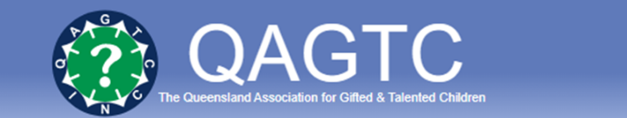
QAGTC 2023 State Conference – 17th and 18th March
Venue – Brisbane Convention and Exhibition Centre and Zoom attendance Friday 17th only
Program Information and Registration at www.qagtc.com.au
Friday 17th March
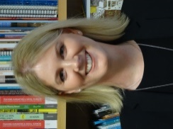
Dr Gemma Scarparolo - What do gifted children want their teachers to know? Implications for policy and practice
Intellectually gifted students have specific educational needs. Therefore, it is valuable to learn about the experiences of these students and their parents to enhance teachers' knowledge and understanding to inform practice and provide the most appropriate educational experience for gifted students. In this keynote, Gemma will present an overview of relevant literature and prompt attendees to consider the implications for practice.

Bio: Gemma is a Senior Lecturer and the Master of Teaching Primary Course Coordinator in the Graduate School of Education at the University of Western Australia. Her research focuses on diversity, inclusive teaching (specifically differentiation and the universal design for learning) and teacher education. She is passionate about preparing pre-service teachers to be inclusive, responsive and empathetic teachers who know effective inclusive teaching approaches and understand how aspects of diversity, such as intellectual giftedness, can impact students and their parents.

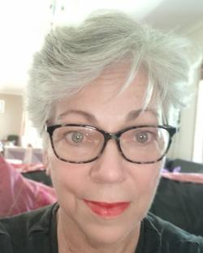
Sue Prior – Twice-Exceptionality and inclusive education. What do we know, what can we do?
Students with twice-exceptionality (2e) are an embodiment of paradox and possibility in our schools. 2e is an umbrella term used to describe students who are both gifted and have some kind of disability. However, this is a small heterogeneous population of students in special, gifted and mainstream education who may also be indigenous, learning English as another language, LGBTQI or experiencing a combination of other differences. As such 2e presents a unique opportunity to blend best practices through a systems approach across our fields, particularly as we transition to more inclusive and collaborative school communities valuing diversity. What does the inclusive education literature recommend for students experiencing twice-exceptionality? Have other interests hijacked inclusive education? Does inclusion really mean whole school approaches must include “each and every student”? Multi-tiered systems of support, dual differentiation and other approaches will be offered in this keynote including a call to action.
Bio: Sue is an international inclusive education consultant currently living in Brisbane. She has worked as a teacher in schools across three countries, including three states of Australia and as a system gifted education consultant in Brisbane, during 30+ years in education. Sue is a serial Doctoral student, and international presenter with a Master of Education degree in gifted education and leadership and a Bachelor of Education degree in Special Needs. She is also trained as a SENG model parent group facilitator. Her evidence-based research has grown from creative, collaborative, and inclusive education projects to designing and delivering personalised and strategic support for diverse learners and schools.

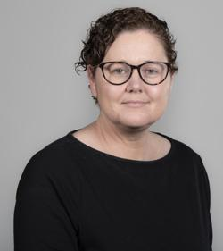
Dr Genevieve Thraves - Aboriginal Perspectives of Giftedness: What we need to learn from these
School-based understandings of ‘giftedness’ are often crafted from a particular cultural view of what constitutes intelligence and achievement. Additionally, common views of giftedness often associate intelligence with particular traits, aptitudes, and behaviours. This leads to a situation where gifted Aboriginal students are often overlooked in terms of their intellectual giftedness, but also in terms of their cultural gifts. This presentation will explore how the concept of giftedness is viewed and understood, and importantly expressed, for some of Australia’s Aboriginal peoples. The presentation will also present some practical approaches that have been successful in identifying and supporting gifted Aboriginal students; both those that are intellectually gifted and those that might be considered culturally gifted by their community. Finally, the question will be posed: ‘What do we need to learn from Aboriginal perspectives of giftedness?’

Bio: Dr Genevieve Thraves (PhD) is a Lecturer in Learning and teaching, and Inclusive Education, in the School of Education, University of New England. Her research is focused on gifted and talented education. Genevieve’s work has informed policy and improvement agendas at a national level. As the recipient of over $1,400,000 in funding, she has had the opportunity to work closely with industry. Genevieve was the 2022 recipient of the John Geake Outstanding thesis award which is presented bi-annually by the Australian Association for the Education of the Gifted and Talented. She currently coordinates the Bachelor of Special and Inclusive Education (Primary at UNE, and has a strong teaching record, at both the school and tertiary level, in gifted education.

Saturday 18th March - Keynote
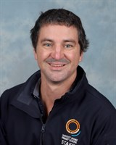
Bio -Kyle Hattie is a Year 6 Teacher at Harvest Home Primary school (1000 students in north Melbourne). He has taught at all levels of primary school in NZ and Victoria, specialised in innovative learning environments, and was an acting Assistant Principal of Stonefields in Auckland. He is elected into the Exemplary Teaching Program, has been a Learning Specialist, and coordinated teachers in “The nature of learning” project to identify students and teachers conceptions of learning, leading a team in developing the school’s 7 Learning Dispositions, and now integrating into the schools model of teaching and learning. He has been published in passion projects, and the nature of learning, and recently co-authored (with John Hattie) 10 Steps to Developing Great Learners.

10 Steps to develop great Learners - Visible learning for Parents

What can parents and caregivers do to ensure their children develop great learning habits that will help them achieve their maximum at school and in life? This is probably one of the most important questions any parent can ask, and now John Hattie, one of the most respected and renowned education researchers in the world, draws on his globally famous Visible Learning research to provide some answers.
Writing this book with his son Kyle, himself a respected teacher, the Hatties offer a 10-step plan to nurture curiosity and intellect and provide a home environment that encourages and values learning. These simple steps, based on the strongest of research evidence and packed full of practical advice, can be followed by any parent or caregiver to support and enhance learning and maximize the potential of their children. Areas covered include:
- Communicating effectively with teachers
- Being the ‘first learner’ and demonstrating openness to new ideas and thinking
- Choosing the right school for your child
- Promoting the ‘language of learning’
- Having appropriately high expectations and understanding the power of feedback

The Queensland School Library Association supports School Libraries across Queensland, providing advocacy, communication, and information to our members.

From February 13-17, 2023, we are celebrating QSLW – Queensland School Library Week to highlight the work accomplished by qualified teacher-librarians and library staff in improving literacy and research skills in print and digital formats. We would like to advertise this event to all schools, not only those who are members of QSLA.
Our 2023 theme is School Libraries – Devoted to You.
You can download our free poster, bookmark, email signature, and social media image from https://www.qsla.org.au/qslw

Schools can also encourage students to participate in the Primary and Secondary competitions. Winners will each receive a $50 book voucher and their school will receive a $100 book voucher.

Entries will be accepted from Monday 13 February until Friday 3 March. Further details are provided in the website link above.

Can you contribute to providing a snapshot of education for high-ability learners in Australia?
Researchers from the University of Wollongong are inviting educators who lead gifted education in Australian schools to share aspects of their work to better understand the current state of this field in 21st century Australia. Participants would be people who are currently or have historically taken responsibility for a gifted education program across a single school or multiple schools, either as an individual or as part of a team. The planned study will gather information regarding models of gifted education which guide implementation of services in both Primary and Secondary contexts.
The two phases of this mixed-methods study include an online survey and a small number of interviews, participants can choose to volunteer to complete the survey, survey and interview (if selected for the interview phase), or neither component. The results of this research will help both experienced and novice leaders to better meet the needs of high ability students by providing guidance for applying models in different contexts.
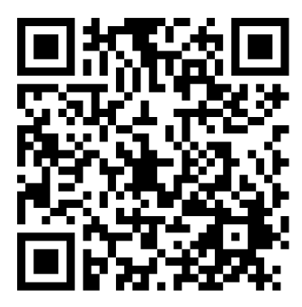
Click on the link HERE or use the QR code to access the Participant Information Sheet and online survey
for this study.
https://uow.au1.qualtrics.com/jfe/form/SV_0xIuAMkeeamr5P0

